I. Discrete-Time Signals and Systems

Discrete-time signals are sequences of real or complex numbers denoted x(n) or x_{n} where n is an integer, or simply x. The most basic signal is the impulse:

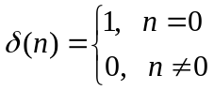

Any sequence can be expressed as a linear combination of shifted impulses:

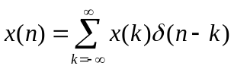

Another basic signal is the step:

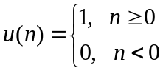

We can express the step in terms of the impulse, and vice-versa, as follows:

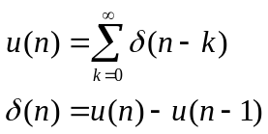

The most general discrete-time exponential is 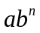 where a and b are complex. If 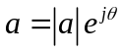 and 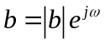, then

The digital frequency of the sinusoids (in radians) is ω, and the phase angle (in radians) is θ. Discrete-time sinusoids show some significant differences when compared to analog sinusoids. First, digital frequencies separated by an integer multiple of 2π radians are identical. Consider:

Therefore, we can restrict digital frequencies to an interval of length 2π. We will use one of the following intervals: (-π, π] or [0, 2π). Note that the lowest possible frequency (0) is in the center of the first interval, and at both ends of the second interval. The highest possible frequency is π.

Whereas analog sinusoids are always periodic, discrete-time sinusoids may not be. A sequence x is periodic if there is a positive integer N for which 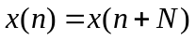 for all n. Clearly, 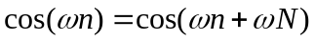 if and only if ωN is an integer multiple of 2π. In other words, the sinusoid is periodic iff ω/2π is a rational number. Check the following examples: 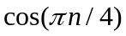 is periodic with N = 8, 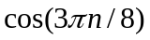 is periodic with N = 16, 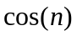 is not periodic. Finally, if x₁ and x₂ are periodic with periods N₁ and N₂, x₁ + x₂ is periodic with period equal to the least common multiple of N₁ and N₂.

Any operation which transforms one sequence (the input) into another sequence (the output) is a discrete-time system. For example, consider the ideal delay system:

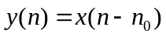

where n₀ is a positive integer, and the moving average system:

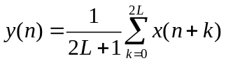

where L is a positive integer and 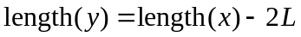.

There are several useful system classes. If input x₁ produces output y₁, and input x₂ produces output y₂, then the system is linear if input ax₁ + bx₂ produces output ay₁ + by₂. The ideal delay and moving average systems are both linear. Another linear system is the accumulator:

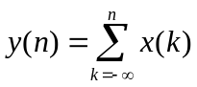

If a shift in the input causes an identical shift in the output, the system is said to be time invariant. The ideal delay and accumulator systems are time invariant. One way to check for time invariance is illustrated using the accumulator. Let y(n) be the output produced by x(n) and let y₁(n) be the output produced by x₁(n) = x(n-n₀) where n₀ is any integer. Then

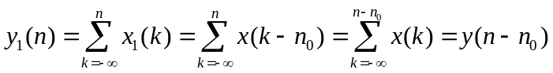

A system is causal if the current output value does not depend on future input values. The ideal delay and the accumulator are causal, but the moving average is not. The backward difference system:

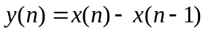

is causal, but the forward difference system:

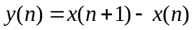

is not. Both are linear and time invariant, however.

A system is stable if every bounded input produces a bounded output. A bounded sequence satisfies 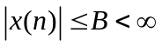 for all n. All the system examples have been stable except the accumulator. To see this, let the input be a step, which is bounded. Then the output is:

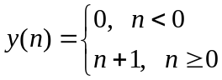

which is unbounded.
Two other important systems are the downsampler:

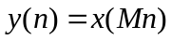

in which M is a positive integer, and the upsampler:

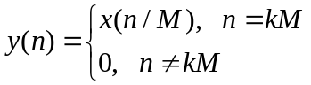

in which k is any integer. They are linear and stable, but not time invariant.

The class of systems which are both linear and time invariant (LTI) is particularly interesting because their behavior is completely characterized by a single sequence, the impulse response. If the input to an LTI system with zero initial conditions is an impulse δ(n), the resulting output is called the impulse response h(n). When the impulse response has finite length, the system is FIR; otherwise it is IIR. Here are the impulse responses for the ideal delay:

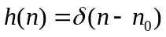

for the accumulator:

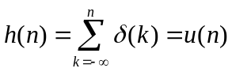

for the forward difference:

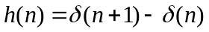

and for the backward difference:

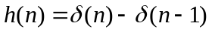

For any LTI system there is a simple relationship between input and output. Time invariance implies that the input δ(n-n₀) will produce the output h(n-n₀), and thus linearity implies that the input will produce the output

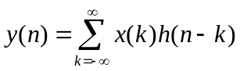

The operation on the right side of the equation is called convolution. The output of an LTI system is the convolution of the input and the impulse response. Keep in mind that this output is only the forced response of the system since we are assuming that the initial conditions are zero. We will often use the shorthand notation:

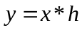

Since 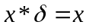, the identity system has an impulse for its impulse response. If two systems connected in series can be combined to produce the identity system, those two systems are inverses of each other. For example, the accumulator and backward difference systems are inverses of each other because their series connection is the system with impulse response .

Convolution is commutative, associative, and distributive:

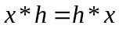
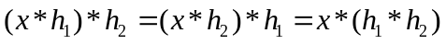
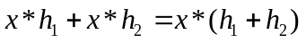
These properties imply that (1) the input and impulse response can be interchanged without affecting the output, (2) in a series connection of two systems, the order is irrelevant to the output, and the two systems can be combined by convolving their impulse responses, and (3) two systems connected in parallel can be combined by adding their impulse responses.

Note that if the sequences x and h have lengths N₁ and N₂, then x*h has length N₁ + N₂ – 1. When x and h have finite length, the convolution can be written in matrix form. For example, if

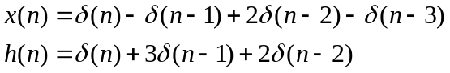

Then

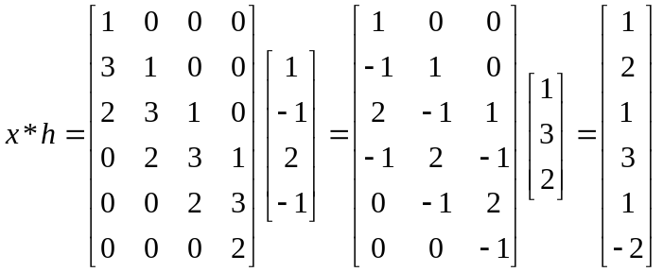

The matrices have Toeplitz structure.

The stability and causality of LTI systems can be checked using the impulse response. Take magnitudes of both sides of the convolution equation:

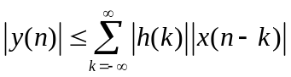

If x is bounded, then y will be bounded and the system will be stable iff

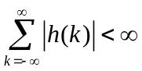
By examining the convolution

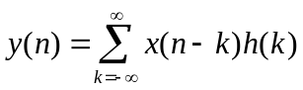

one can see that the system will be causal iff h(k) = 0 for all negative k.

Homework 1 (due 12 Sept.)

1. (a) Show how to use a single statement to reverse the order of a sequence x in Matlab without using the flip function. (b) Give a nontrivial example.

2. (a) Show how to use a single statement to downsample a sequence x by an integer factor M in Matlab without using the downsample function. (b) Give a nontrivial example.

3. (a) Show how to use two statements to upsample a sequence x by an integer factor M in Matlab without using the upsample function. (b) Give a nontrivial example.

4. (a) Create a handle to an anonymous function that evaluates the unit step u(n) in Matlab. (b) Use the result to create a stem plot of u(1-2n) for n = -10:10.

5. Given the periodic sequence 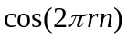, determine a rule for finding the period N from r.

6. If the period of is N, what is the period of 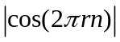?

*7. Write a Matlab function which computes the output sequence of the moving average system by finding the mean of a certain matrix formed from the input sequence. The first line should be: function y = mav(x, L). Use Matlab’s mean and hankel functions and do not use any loops. Do not form an unnecessarily large matrix.

8. Using one Matlab statement, without “if” or logical tests, implement the following. Given a vector x, if x is a column, do nothing; but if x is a row, make it a column.

*9. Write a Matlab function which computes the convolution of two vectors via matrix – vector multiplication. The first line should be: function y = mconv(h, x). Use Matlab’s toeplitz function and do not use any loops. Make sure your code chooses the faster of the two options: h*x or x*h, and use the result from problem 8. Check the accuracy of your code by using Matlab’s conv function.
10. (a) Let y be the result of upsampling x by a factor of M. If we then downsample y by a factor of M, do we exactly recover x? (b) Let y be the result of downsampling x by a factor of M. If we then upsample y by a factor of M, do we exactly recover x? (c) Do upsampling and downsampling commute?

